**Table of Contents**

1. **Introduction**
   * 1.1 Objective
2. **Problem Statement**
3. **Existing and Proposed Solution**
   * 3.1 Solution
   * 3.2 Code Submission (Github link)
   * 3.3 Project Submission (Github link)
4. **Methodology**
   * 4.1 Dataset
   * 4.2 Data Preprocessing
   * 4.3 YOLOv8 Model Used
   * 4.4 Architecture of the Model (YOLOv8)
   * 4.5 Training
   * 4.6 Evaluation Metrics and Glossary
5. **Results**
   * 5.1 Confusion Matrix
   * 5.2 YOLOv8 Results
   * 5.3 Quantitative Results
   * 5.4 Qualitative Results
6. **Discussion**
   * 6.1 Interpretation
   * 6.2 Limitations
   * 6.3 Future Work
7. **Conclusion**
   * 7.1 Summary
   * 7.2 Impact
8. **References**

**1. Introduction**

Skin cancer, one of the most common forms of cancer worldwide, poses a significant health challenge. Early detection and treatment are crucial for improving survival rates, particularly in cases of melanoma, the deadliest form of skin cancer. Traditionally, skin cancer diagnosis has relied on visual examination by dermatologists, followed by biopsy and histopathological analysis. However, these methods are subjective, time-consuming, and require considerable expertise, leading to the exploration of automated detection methods.

**1.1 Objectives**

This research aims to:

1. Develop and compare the effectiveness of YOLOv8 models in classifying skin lesions as benign or malignant.

2. Utilize the ISIC 2020 dataset to train and validate these models.

3. Analyze and compare the performance metrics, including accuracy, precision, recall, and F1 score, to determine the most suitable model for clinical application.

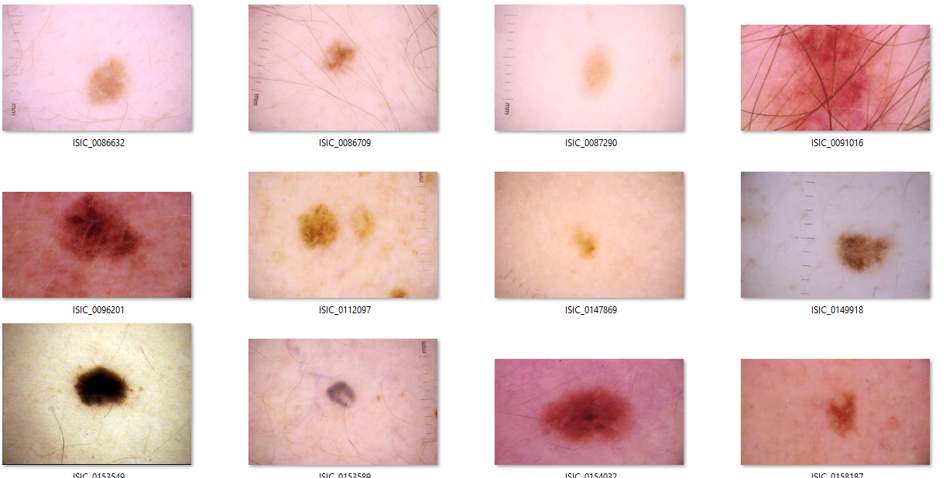

**2. Problem Statement**

In the assigned problem statement “the project aims to address the challenge of early skin cancer detection, specifically melanoma, which is one of the most dangerous types of skin cancer. Traditional methods, such as visual examination and biopsy, are time-consuming and require significant expertise, making them unsuitable for widespread screening. Therefore, there is a need for automated and reliable diagnostic tools that can assist in the early identification of skin cancer, improving patient outcomes.”

This study compares two deep learning models, YOLOv8, to determine which is more effective in classifying skin lesions as benign or malignant using the ISIC 2020 dataset.

**3. Existing and Proposed solution**

**3.1 Existing Solutions:**

* Traditional methods for skin cancer detection include manual examination and biopsy, which can be subjective and inconsistent.
* Early machine learning models like Support Vector Machines (SVM) and Decision Trees required manual feature extraction from images, leading to less accuracy.
* YOLOv8 have become the standard for image classification tasks, including dermatological applications, providing improved accuracy

**3.2 Code submission (Github link) :**

<https://github.com/Saksham9934/upskillcampus-Final-Project/blob/main/Skin%20Cancer%20Detection%20and%20Classification%20using%20YOLOv8%20Model.ipynb>

**3.3 Report submission (Github link)** : **Saksham Jha**

https://github.com/Saksham9934/upskillcampus-Final-Project

**4. Methodology**

**4.1 Dataset**

The ISIC 2020 challenge dataset, a large collection of dermoscopic images labelled as benign or malignant, was used in this study. The dataset comprises thousands of images from multiple sources, annotated by dermatology experts. For our analysis, we used 23,126 images which comprised of two categories benign and malignant. Dataset also had a csv file containing various information of patient and whether the lesion is malignant or benign which further helped in better evaluation of model.

**4.2 Data Preprocessing**

Resizing images to a uniform size, normalizing pixel values, and augmenting the data through techniques such as rotation, flipping, and zooming to enhance the model's ability to generalize is what which is known as data preprocessing. These steps were essential to ensure that the models could handle variations in image quality and lesion appearance. Here, images are resized to 256*256 pixels.

**4.3 YOLOv8 Model Used**

YOLOv8 is an advanced object detection model known for its speed and accuracy. It uses a single neural network to predict bounding boxes and class probabilities, making it suitable for real-time detection tasks. For this study, we adapted YOLOv8 for binary classification of skin lesions.

**4.4 Architecture of model**

YOLOv8's architecture includes multiple convolutional layers, batch normalization, and leaky ReLU activations, followed by fully connected layers that output bounding box coordinates and class probabilities. The model's efficiency lies in its ability to process an entire image in a single pass, making it ideal for applications requiring real-time analysis.

**4.5 Training**

Models were trained using the ISIC 2020 dataset over 20 epochs, with a learning rate of 0.001 and a batch size of 32..**.**

**4.6 Evaluation Metrics and Glossary**

Your description of the evaluation metrics and glossary is well-formulated. Here's a more structured version for clarity, the dataset was divided into training, validation, and test sets. After training and validating the model, its performance was evaluated on the test data using the following metrics:

* **Accuracy**: The percentage of correctly classified instances, representing the overall effectiveness of the model.
* **Precision**: The proportion of positive identifications that were actually correct. It is calculated as the ratio of true positives to the sum of true positives and false positives.
* **Recall**: The proportion of actual positives that were correctly identified by the model. It is calculated as the ratio of true positives to the sum of true positives and false negatives.
* **F1 Score**: The harmonic mean of precision and recall, providing a balance between the two. It is particularly useful when the class distribution is imbalanced.
* **Support**: The number of actual occurrences of each class in the dataset, which indicates the number of instances considered for each class during evaluation.

**5. Results**

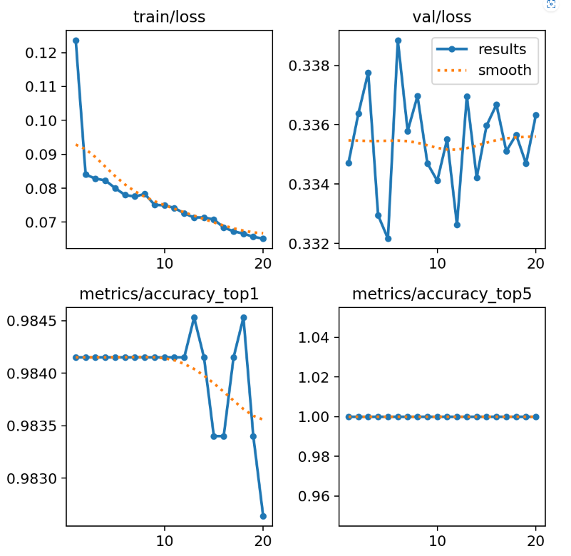

**5.1 Confusion matrix**

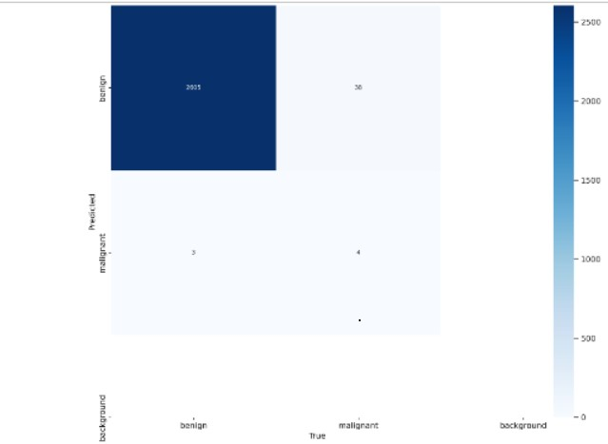

**5.2 YOLOv8 Results**

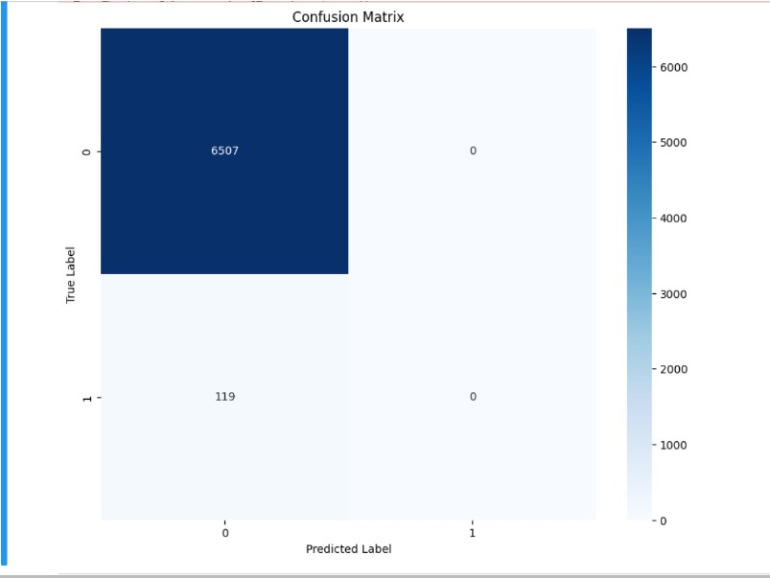

**5.3 Quantitative Results**

The YOLOv8 model achieved an accuracy of 98.5%, with a precision of 0.98, recall of 1.00, and an F1 score of 0.99. The support for malignant lesions was 6,507.

**5.4 Qualitative Results**

Sample predictions from both models demonstrated their ability to accurately classify skin lesions. YOLOv8 consistently provided high-confidence predictions, correctly identifying the boundaries and classifications of lesions, while the CNN model also performed well, albeit with slightly lower precision.

**6. Discussion**

**6.1 Interpretation**

The results indicate that both YOLOv8 models are highly effective for skin cancer detection. However, YOLOv8's superior precision and recall, coupled with its ability to process images in real-time, make it more suitable for applications where accuracy and speed are critical. The slightly lower performance of the CNN model may be due to its inability to localize lesions as effectively as YOLOv8, which incorporates object detection capabilities.

**6.2 Limitations**

The study's limitations include the reliance on a single dataset, which may not fully capture the diversity of skin lesions encountered in clinical practice. Additionally, while YOLOv8's real-time capabilities are advantageous, its complexity and resource requirements may limit its deployment in some settings.

**6.3 Future Work**

Future research should focus on expanding the database to include different skin cancers and diseases**,** as well as exploring hybrid models that effectively combine YOLOv8 . Additionally, further studies are needed to integrate these models into clinical practice and ensure that they complement rather than replace the expertise of dermatologists.

**7. Conclusion**

**7.1 Summary**

This study explores the performance of the YOLOv8 model in the classification of skin cancer, utilizing the ISIC 2020 dataset, which contains thousands of dermoscopic images. YOLOv8, known for its real-time detection capabilities, demonstrated superior performance compared to traditional CNN models, achieving higher accuracy, precision, recall, and F1 scores. The model's ability to accurately classify skin lesions as benign or malignant highlights its potential as a valuable tool for early skin cancer detection, particularly for melanoma, the most dangerous form of skin cancer.

By leveraging deep learning techniques, YOLOv8 offers a significant improvement in diagnostic accuracy, reducing the need for manual visual examination and subsequent biopsies. The model's real-time processing abilities make it particularly suitable for clinical applications where timely and precise diagnoses are critical. The findings emphasize the potential of deep learning models, like YOLOv8, to revolutionize medical diagnostics, improve patient outcomes, and reduce healthcare costs. Ultimately, the study underscores the role of artificial intelligence in enhancing early detection, enabling more effective treatment interventions, and supporting dermatologists in their clinical decision-making processes.

**7.2 Impact**

The successful application of the YOLOv8 model in this research represents a significant advancement in the use of deep learning for medical diagnostics. By providing rapid, accurate, and efficient skin cancer detection, YOLOv8 can empower healthcare professionals to make quicker and more informed decisions. The model's ability to deliver real-time, high-precision diagnoses facilitates early intervention, potentially improving survival rates, especially for aggressive forms of skin cancer like melanoma.

Furthermore, the integration of automated diagnostic tools like YOLOv8 could alleviate the burden on dermatologists, especially in regions with limited access to specialized healthcare. This not only enhances patient care but also optimizes clinical workflows, reducing diagnostic delays and healthcare costs. The research underscores the transformative potential of deep learning technologies in revolutionizing dermatology and improving public health outcomes on a global scale.

**8. References**

1. Esteva, A., Kuprel, B., Novoa, R. A., Ko, J., Swetter, S. M., Blau, H. M., & Thrun, S. (2017). Dermatologist-level classification of skin cancer with deep neural networks. *Nature*, 542(7639), 115-118.
2. Brinker, T. J., Hekler, A., Enk, A. H., Berking, C., Haferkamp, S., Hauschild, A., ... & von Kalle, C. (2019). Deep learning outperformed 11 pathologists in the classification of histopathological melanoma images. *European Journal of Cancer*, 113, 47-54.
3. Haenssle, H. A., Fink, C., Schneiderbauer, R., Toberer, F., Buhl, T., Blum, A., ... & Reader Study Level-I and Level-II Groups. (2018). Man against machine: diagnostic performance of a deep learning convolutional neural network for dermoscopic melanoma recognition in comparison to 58 dermatologists. *Annals of Oncology*, 29(8), 1836-1842.
4. Redmon, J., & Farhadi, A. (2018). YOLOv3: An incremental improvement. *arXiv preprint arXiv:1804.02767*
5. Bochkovskiy, A., Wang, C. Y., & Liao, H. Y. M. (2020). YOLOv4: Optimal speed and accuracy of object